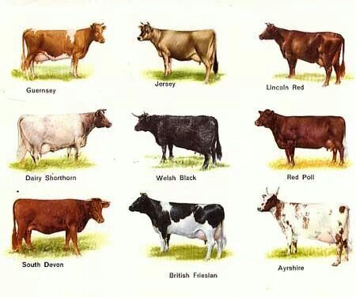
DAIRY COWS IMAGES

